Completed by___________________________________________ on ____________________

BASICS
Mother's Name _________________________________________________________________
Her Parents were________________________________________________________________
Her Grandparents were___________________________________________________________
And __________________________________________________________________________

NAMES
I called my Mother: _____________________________________________________________
Her family called her____________________________________________________________
She called me__________________________________________________________________
When I was in trouble my she called me _____________________________________________

DETAILS
She worked at/as_______________________________________________________________
Her favorite color was___________________________________________________________
My favorite meal that she cooked__________________________________________________
Her hobbies were_______________________________________________________________
(Other) _______________________________________________________________________
(Other) _______________________________________________________________________
THINGS MOM SAID AND DID
Her favorite saying(s)___________________________________________________________
_____________________________________________________________________________
_____________________________________________________________________________
_____________________________________________________________________________

What she said to encourage me____________________________________________________
_____________________________________________________________________________
_____________________________________________________________________________

What she did to make me feel special_______________________________________________
_____________________________________________________________________________
_____________________________________________________________________________
_____________________________________________________________________________

What I learned from her_________________________________________________________
_____________________________________________________________________________
_____________________________________________________________________________
_____________________________________________________________________________
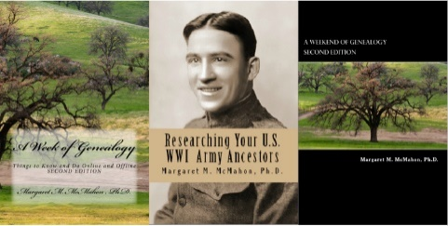
To sign up for A Week Of Genealogy's mailing list for information about future classes, books, and other items of genealogical interest:
https://aweekofgenealogy.com/signup
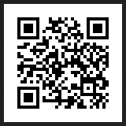
or use this QR code.

